Test Case: tc002_SPX_Dev5_Crear_Requisicion_Spot_Tipo_Cobro_Project
Step 1 - Enter username and password and click to button Enter: Credentials Entered
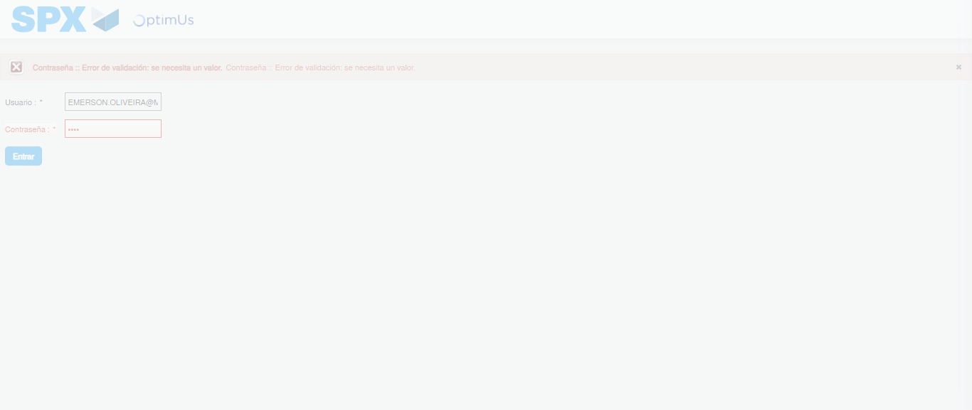Image file-name: QC_Testing-tc002_SPX_Dev5_Crear_Requisicion_Spot_Tipo_Cobro_Project-1784658191540

Step 2 - Select to UEN and Access to Spot Buy Requisitions : UEN Correctly selected and Correct access
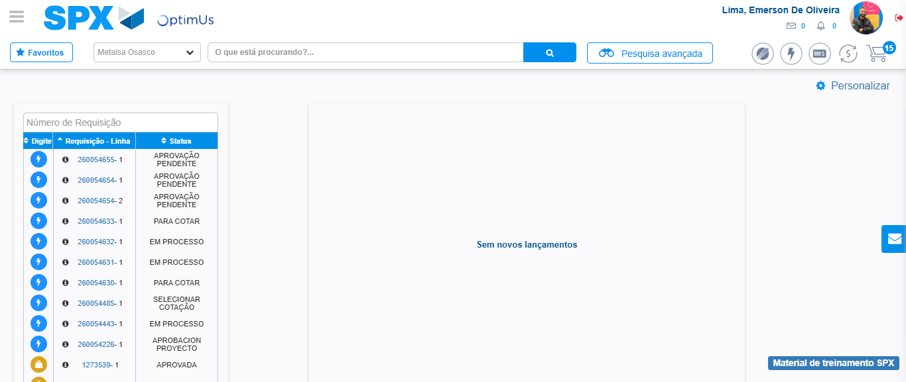Image file-name: QC_Testing-tc002_SPX_Dev5_Crear_Requisicion_Spot_Tipo_Cobro_Project-1784658241572

Image file-name: QC_Testing-tc002_SPX_Dev5_Crear_Requisicion_Spot_Tipo_Cobro_Project-1784658244188

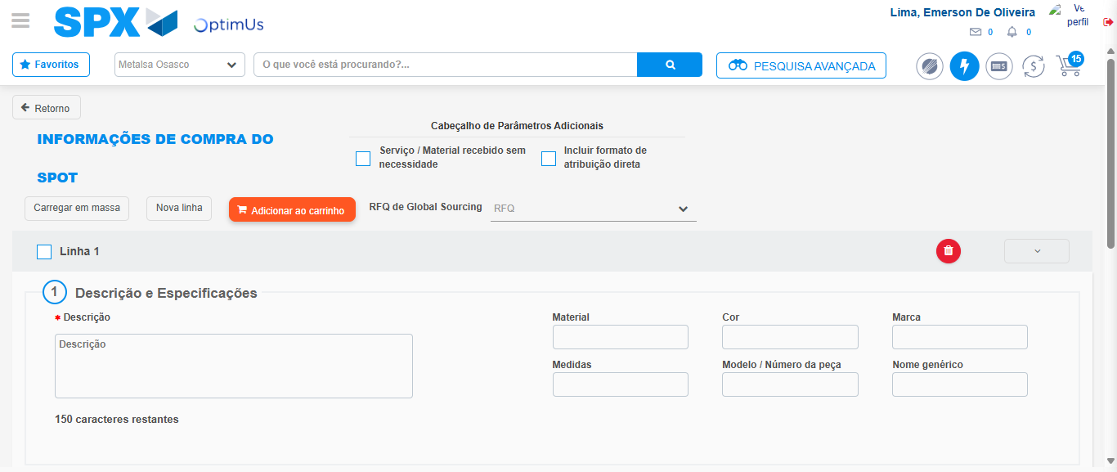Image file-name: QC_Testing-tc002_SPX_Dev5_Crear_Requisicion_Spot_Tipo_Cobro_Project-1784658256512

Step 3 - Data Capture Spot Buy Requisition: Data captured correctly
Image file-name: QC_Testing-tc002_SPX_Dev5_Crear_Requisicion_Spot_Tipo_Cobro_Project-1784658256737

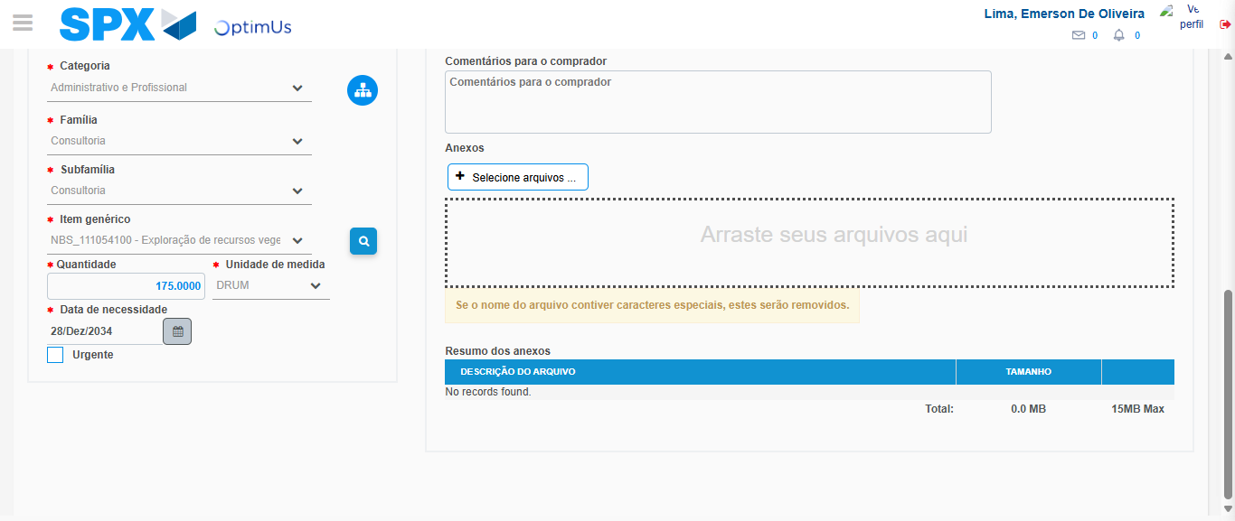Image file-name: QC_Testing-tc002_SPX_Dev5_Crear_Requisicion_Spot_Tipo_Cobro_Project-1784658269054

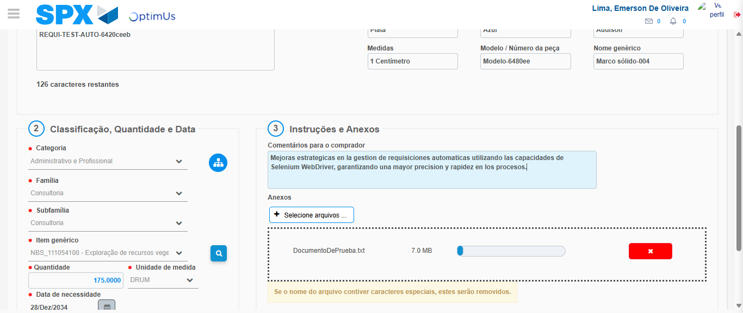Image file-name: QC_Testing-tc002_SPX_Dev5_Crear_Requisicion_Spot_Tipo_Cobro_Project-1784658269783

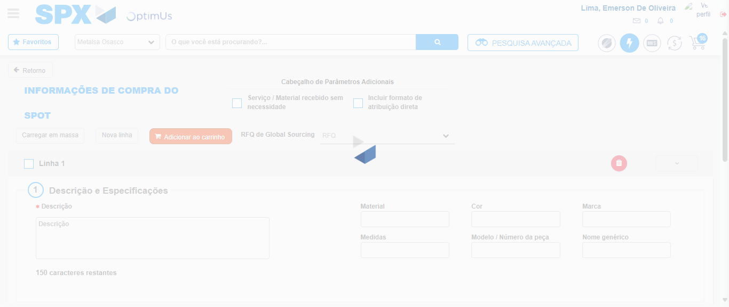Image file-name: QC_Testing-tc002_SPX_Dev5_Crear_Requisicion_Spot_Tipo_Cobro_Project-1784658276161

Step 7 - Return to Main Page SPX : Return to Main Page SPX
Image file-name: QC_Testing-tc002_SPX_Dev5_Crear_Requisicion_Spot_Tipo_Cobro_Project-1784658241572

Image file-name: QC_Testing-tc002_SPX_Dev5_Crear_Requisicion_Spot_Tipo_Cobro_Project-1784658244188

Image file-name: QC_Testing-tc002_SPX_Dev5_Crear_Requisicion_Spot_Tipo_Cobro_Project-1784658256512

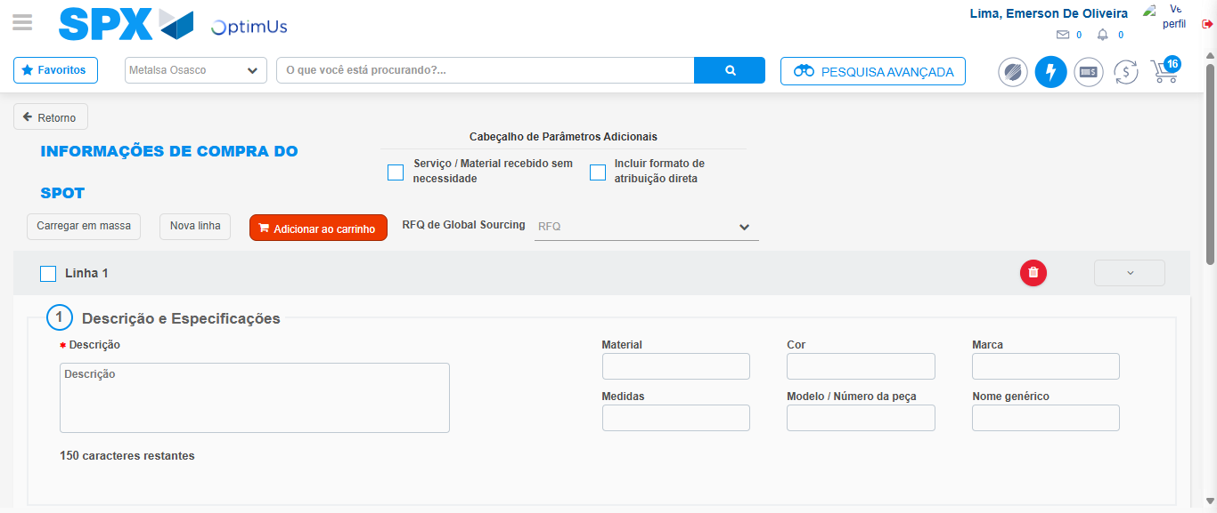Image file-name: QC_Testing-tc002_SPX_Dev5_Crear_Requisicion_Spot_Tipo_Cobro_Project-1784658278371

Image file-name: QC_Testing-tc002_SPX_Dev5_Crear_Requisicion_Spot_Tipo_Cobro_Project-1784658278553

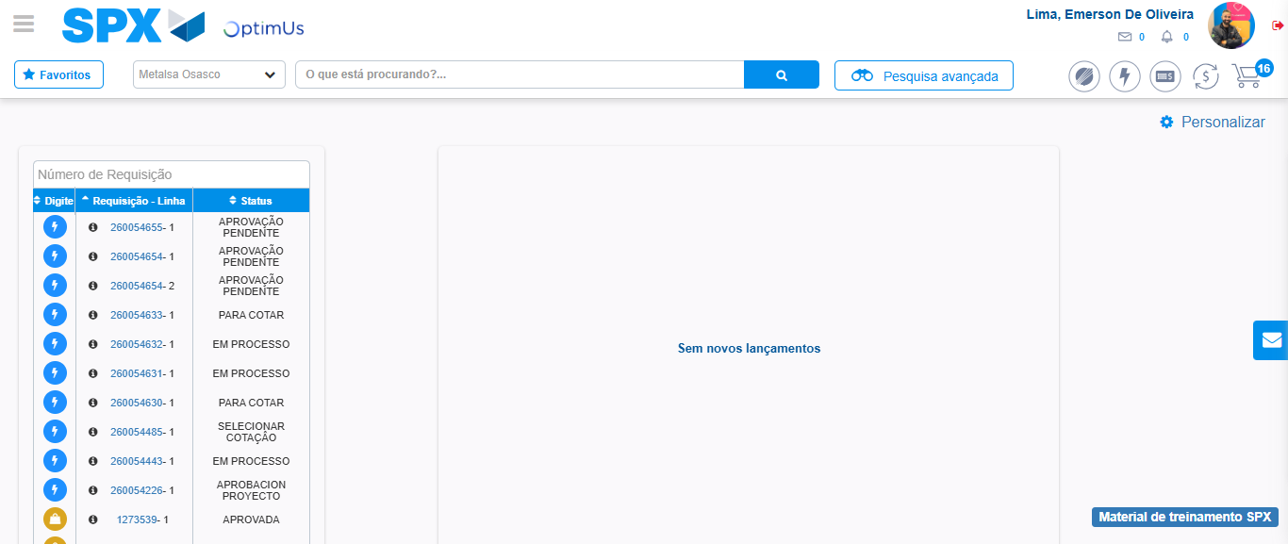Image file-name: QC_Testing-tc002_SPX_Dev5_Crear_Requisicion_Spot_Tipo_Cobro_Project-1784658299559

Step 8 - Log Out : Log Out SPX
Image file-name: QC_Testing-tc002_SPX_Dev5_Crear_Requisicion_Spot_Tipo_Cobro_Project-1784658299741

